**Name:__________________________________ Date: __________________________**

**Computer Science | Mr. Eddie**

**Lesson:**

* Using Online Search Tools to Locate & Evaluate Information Pt. 1

**Objectives:**

* understand the difference between a search engine and a search directory.
* understand the various search techniques such as keyword, Boolean, and phrases.
* explain the importance of computer ethics and proper netiquette, both in the workplace and socially.

Do Now

*Answer the prompts below*

1. **Have you ever gone to a store or a restaurant and the worker was rude to you? Where, and what happened?**

|  |
| --- |
|  |

1. **Have you ever thought to yourself that if you were the boss at that place, you would fire that person?** *Why or why not?*

|  |
| --- |
|  |

1. **What was it about that worker that made you think they were bad at their job or a bad employee? Was there something different they could have done, another way they could have behaved, or something they could have said that would have changed your mind about them?**

|  |
| --- |
|  |

Directory or Search Engine?



**Directory:** In computing, a directory is a file system cataloging structure which contains references to other computer files, and possibly other directories. On many computers, directories are known as folders, or drawers, analogous to a workbench or the traditional office filing cabinet.

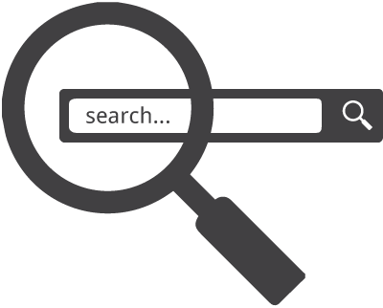

**Search Engine:** A web search engine or Internet search engine is a software system that is designed to carry out web search, which means to search the World Wide Web in a systematic way for particular information specified in a textual web search query.



Job Search

|  |  |  |  |
| --- | --- | --- | --- |
| **No.** | **Job Title** | **Description (Key Roles)** | **Company | Website** |
| **1** |  |  |  |
| **2** |  |  |  |
| **3** |  |  |  |
| **4** |  |  |  |
| **5** |  |  |  |
| **6** |  |  |  |
| **7** |  |  |  |
| **8** |  |  |  |
| **9** |  |  |  |
| **10** |  |  |  |

Searching for Information

**Booleans, Keywords, Phrases**

|  |  |
| --- | --- |
| **Boolean Search: a type of search allowing users to combine keywords with operators (or modifiers) such as AND, NOT and OR to further produce more relevant results.** |  |
| **Keyword Search: a type of search that looks for words anywhere in the record.** |  |
| **Phrase Search: a type of search that allows users to search for documents containing an exact sentence or phrase rather than containing a set of keywords in random order.** |  |

What Is Netiquette?



Online etiquette is ingrained into culture, although etiquette in technology is a fairly recent concept. The rules of etiquette that apply when communicating over the Internet or social networks or devices are different from those applied when communicating in person or by audio or videophone.

**Name:__________________________________ Date: __________________________**

**Computer Science | Mr. Eddie**

Exit Ticket

1. In a few sentences, describe two or more examples of when you would use a directory or search engine, and why?

|  |
| --- |
|  |

1. What is “netiquette” and why is it important?

|  |
| --- |
|  |

1. What is something new you learned today, that you didn’t know before coming to this class.

|  |
| --- |
|  |

1. What are you most excited about this class?

|  |
| --- |
|  |